SYSTEM Caller BADI

Locate Change request Type

i) In SAP easy Access search IMGMDG

ii) Open General settings 🡪 Process Modelling 🡪 Change requests 🡪 then click on Create Chane request Type (follow Highlighted blocks below)

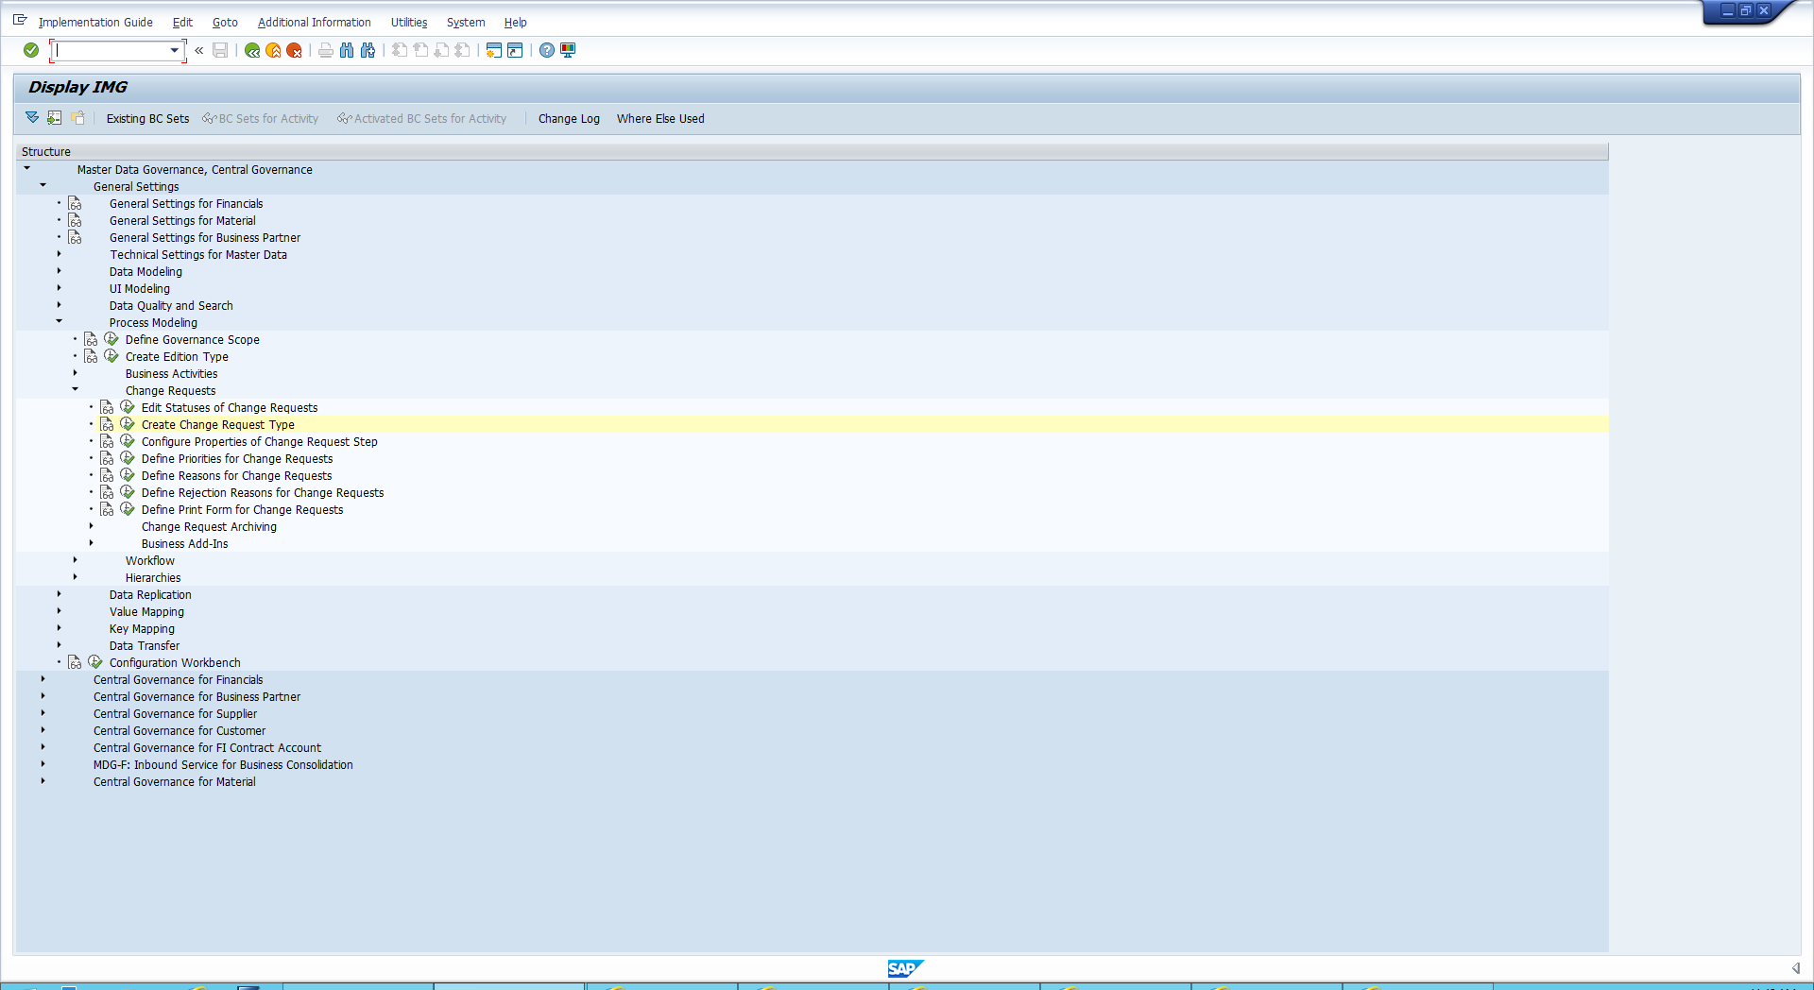

Create the CR

i) Here we will see a list of Change requests. Find change request type: MAT01.

ii) Select the Type and click Copy in the top left corner as highlighted in the image below.

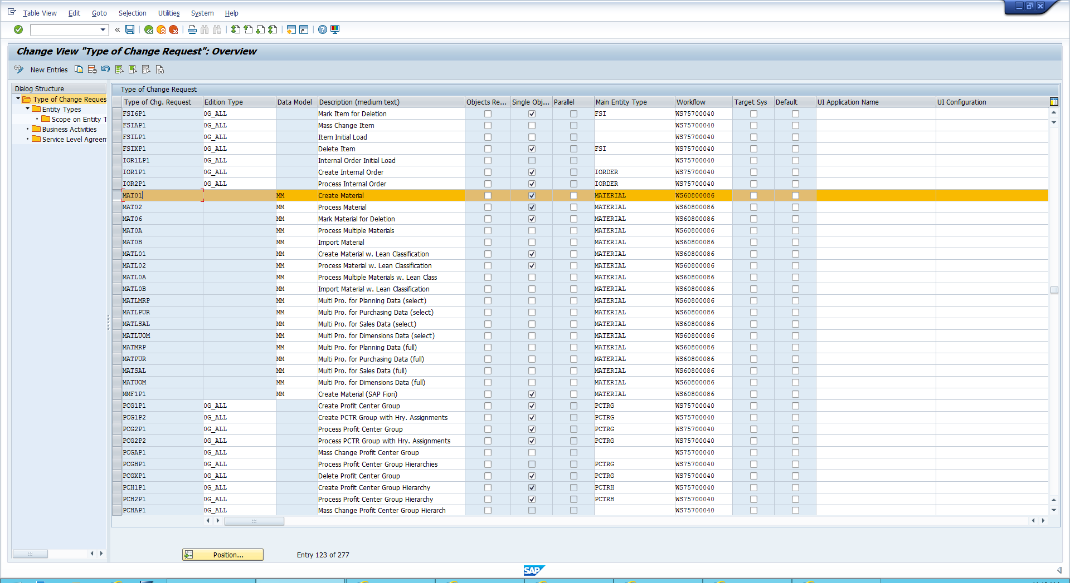

iii) Change the type of change request name eg: EM_MAT20 . Save and click enter

Build steps

i) Open General settings 🡪 Process Modelling 🡪 Workflow 🡪 Rule-Based workflow 🡪 open “define change request steps for Rule-Based Workflow”

ii) Find Mat01select all the values then click copy

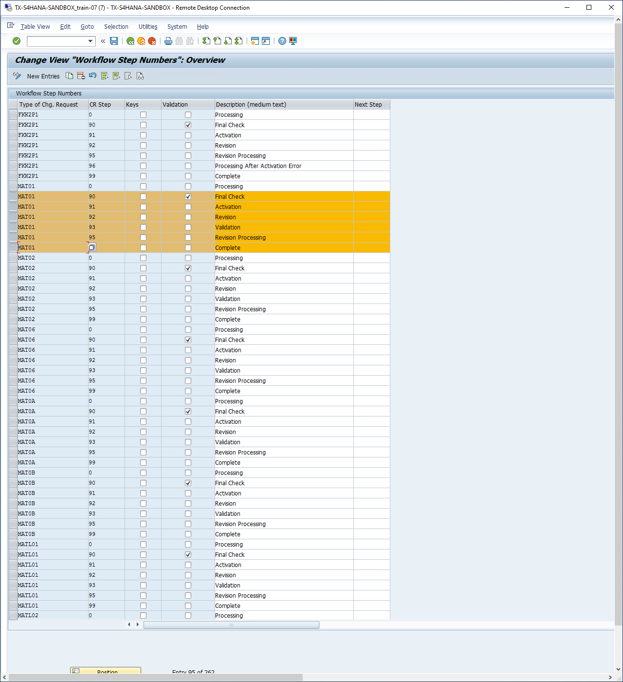

iii)We then change all the Mat01 values to the value of our change request “EM_MAT20”

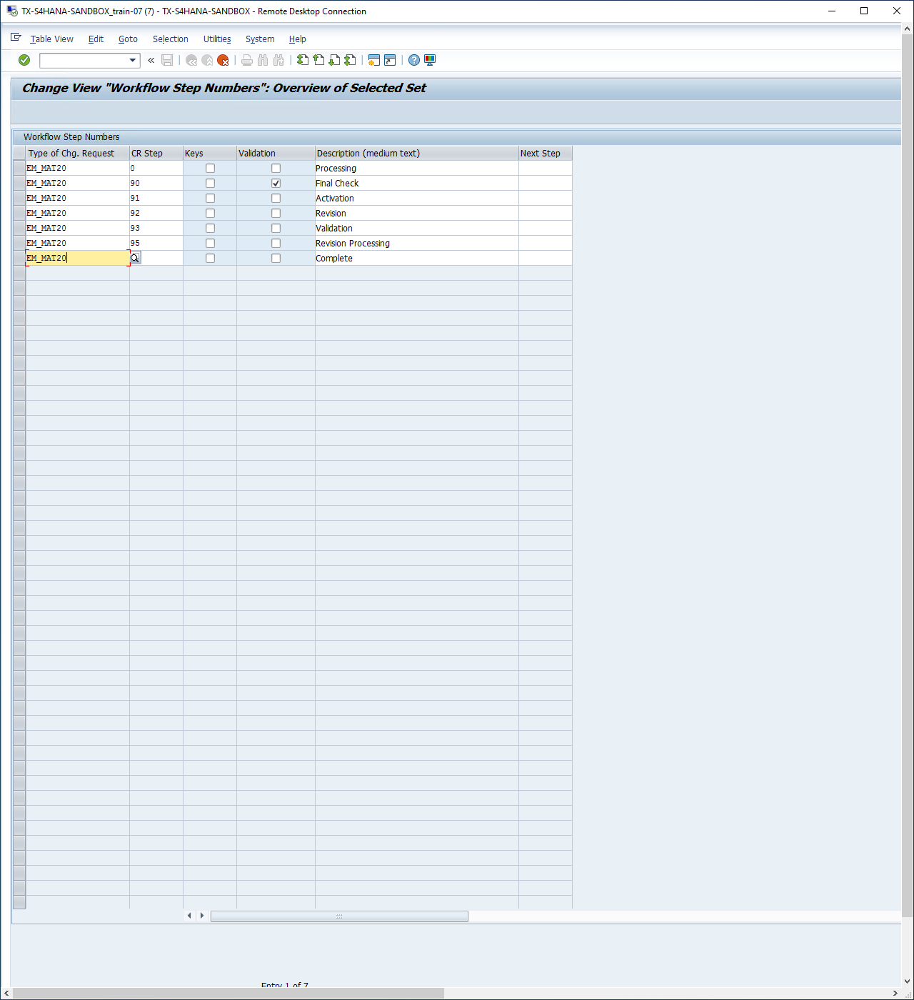

iv) we need to create an extra step, so we select the last step and click copy 🡪 Change the CR step to SY and change the description to as below :

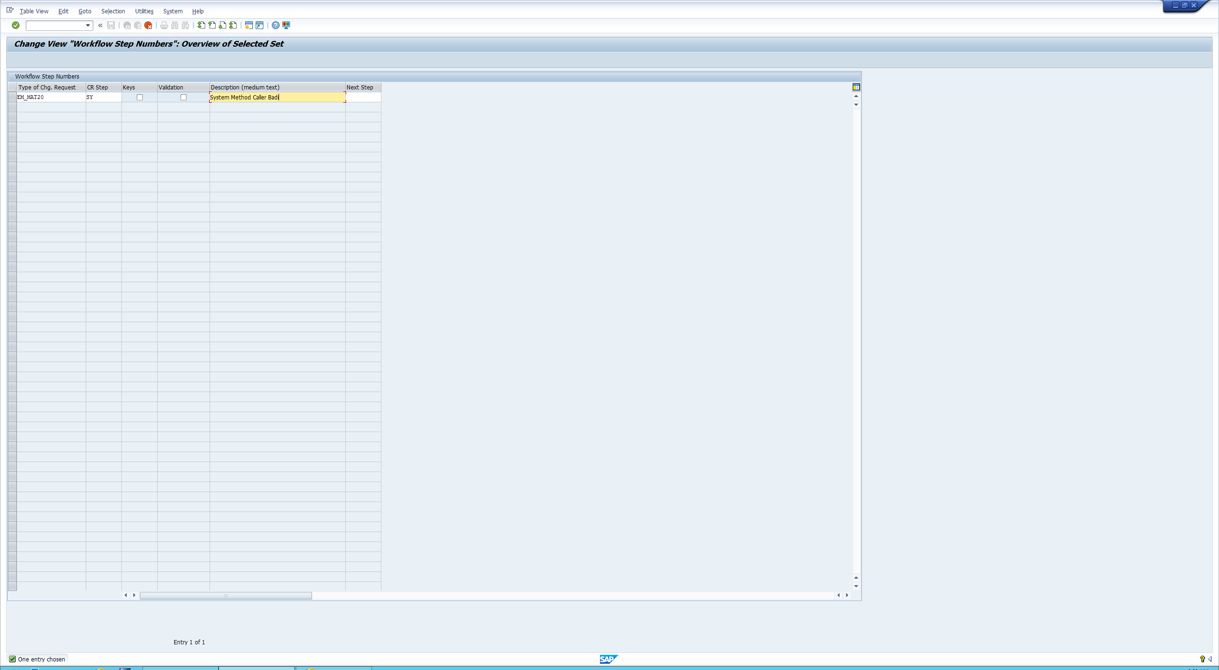

Create a service

i) Open General settings 🡪 Process Modelling 🡪 Workflow 🡪 Rule-Based workflow 🡪 open “define Service Names for Rule-Based Workflow”  
ii) New entries 🡪 Then write down the service nake and description click save

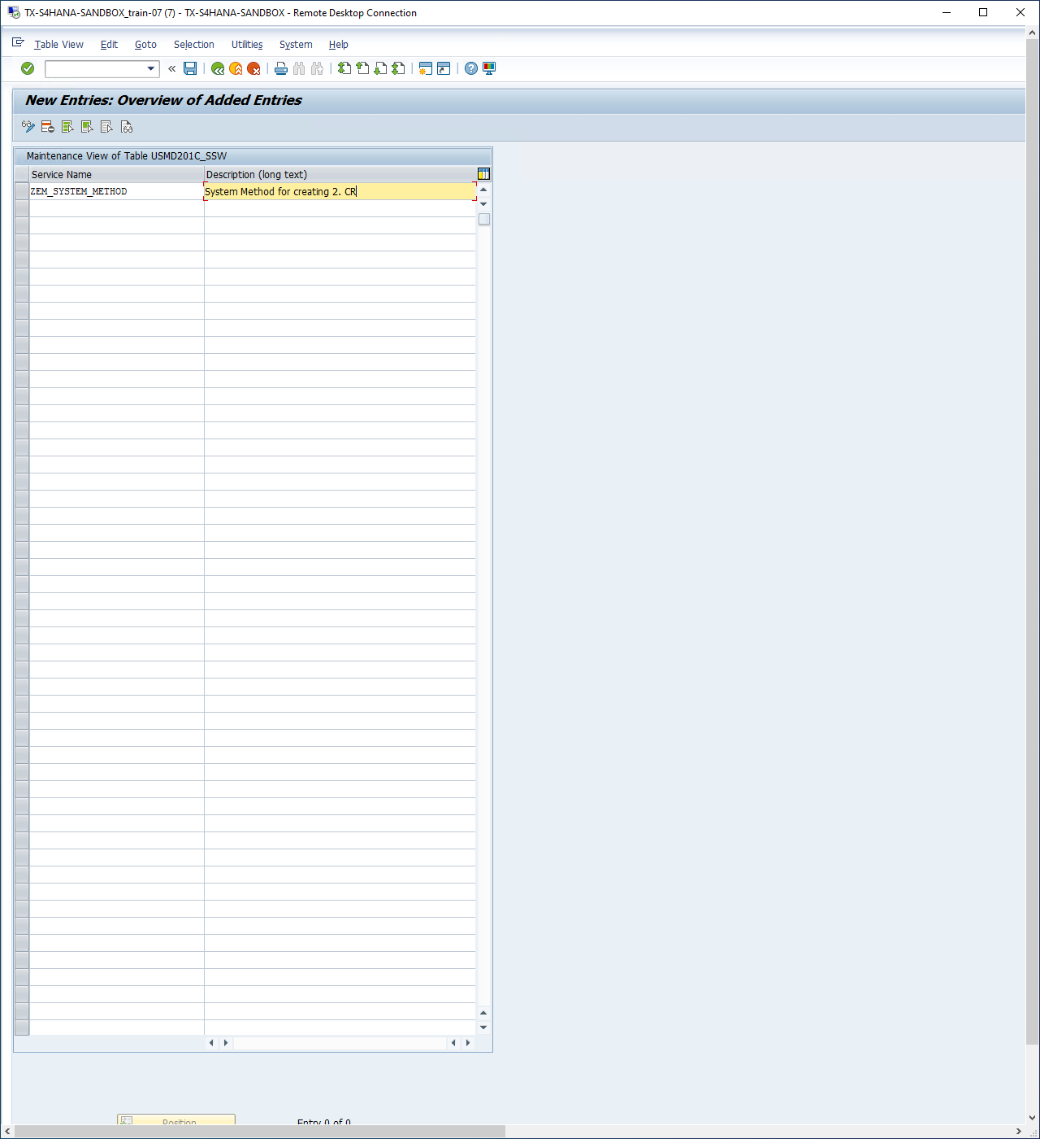

Copy Mat01 Decision table

i) Open General settings 🡪 Process Modelling 🡪 Workflow 🡪 Rule-Based workflow 🡪 open “Configure Rule-Based Workflow”

ii) Enter MAT01

iii) Open decision tables 🡪 Single Value Decision Table click Export as excel. Repeat for the other two tables

iv) Open your Change request “EM_MAT20” 🡪 Open Decision tables 🡪 Single Value Decision table 🡪 Edit 🡪 Additional Actions 🡪 Import the files you just exported for each table

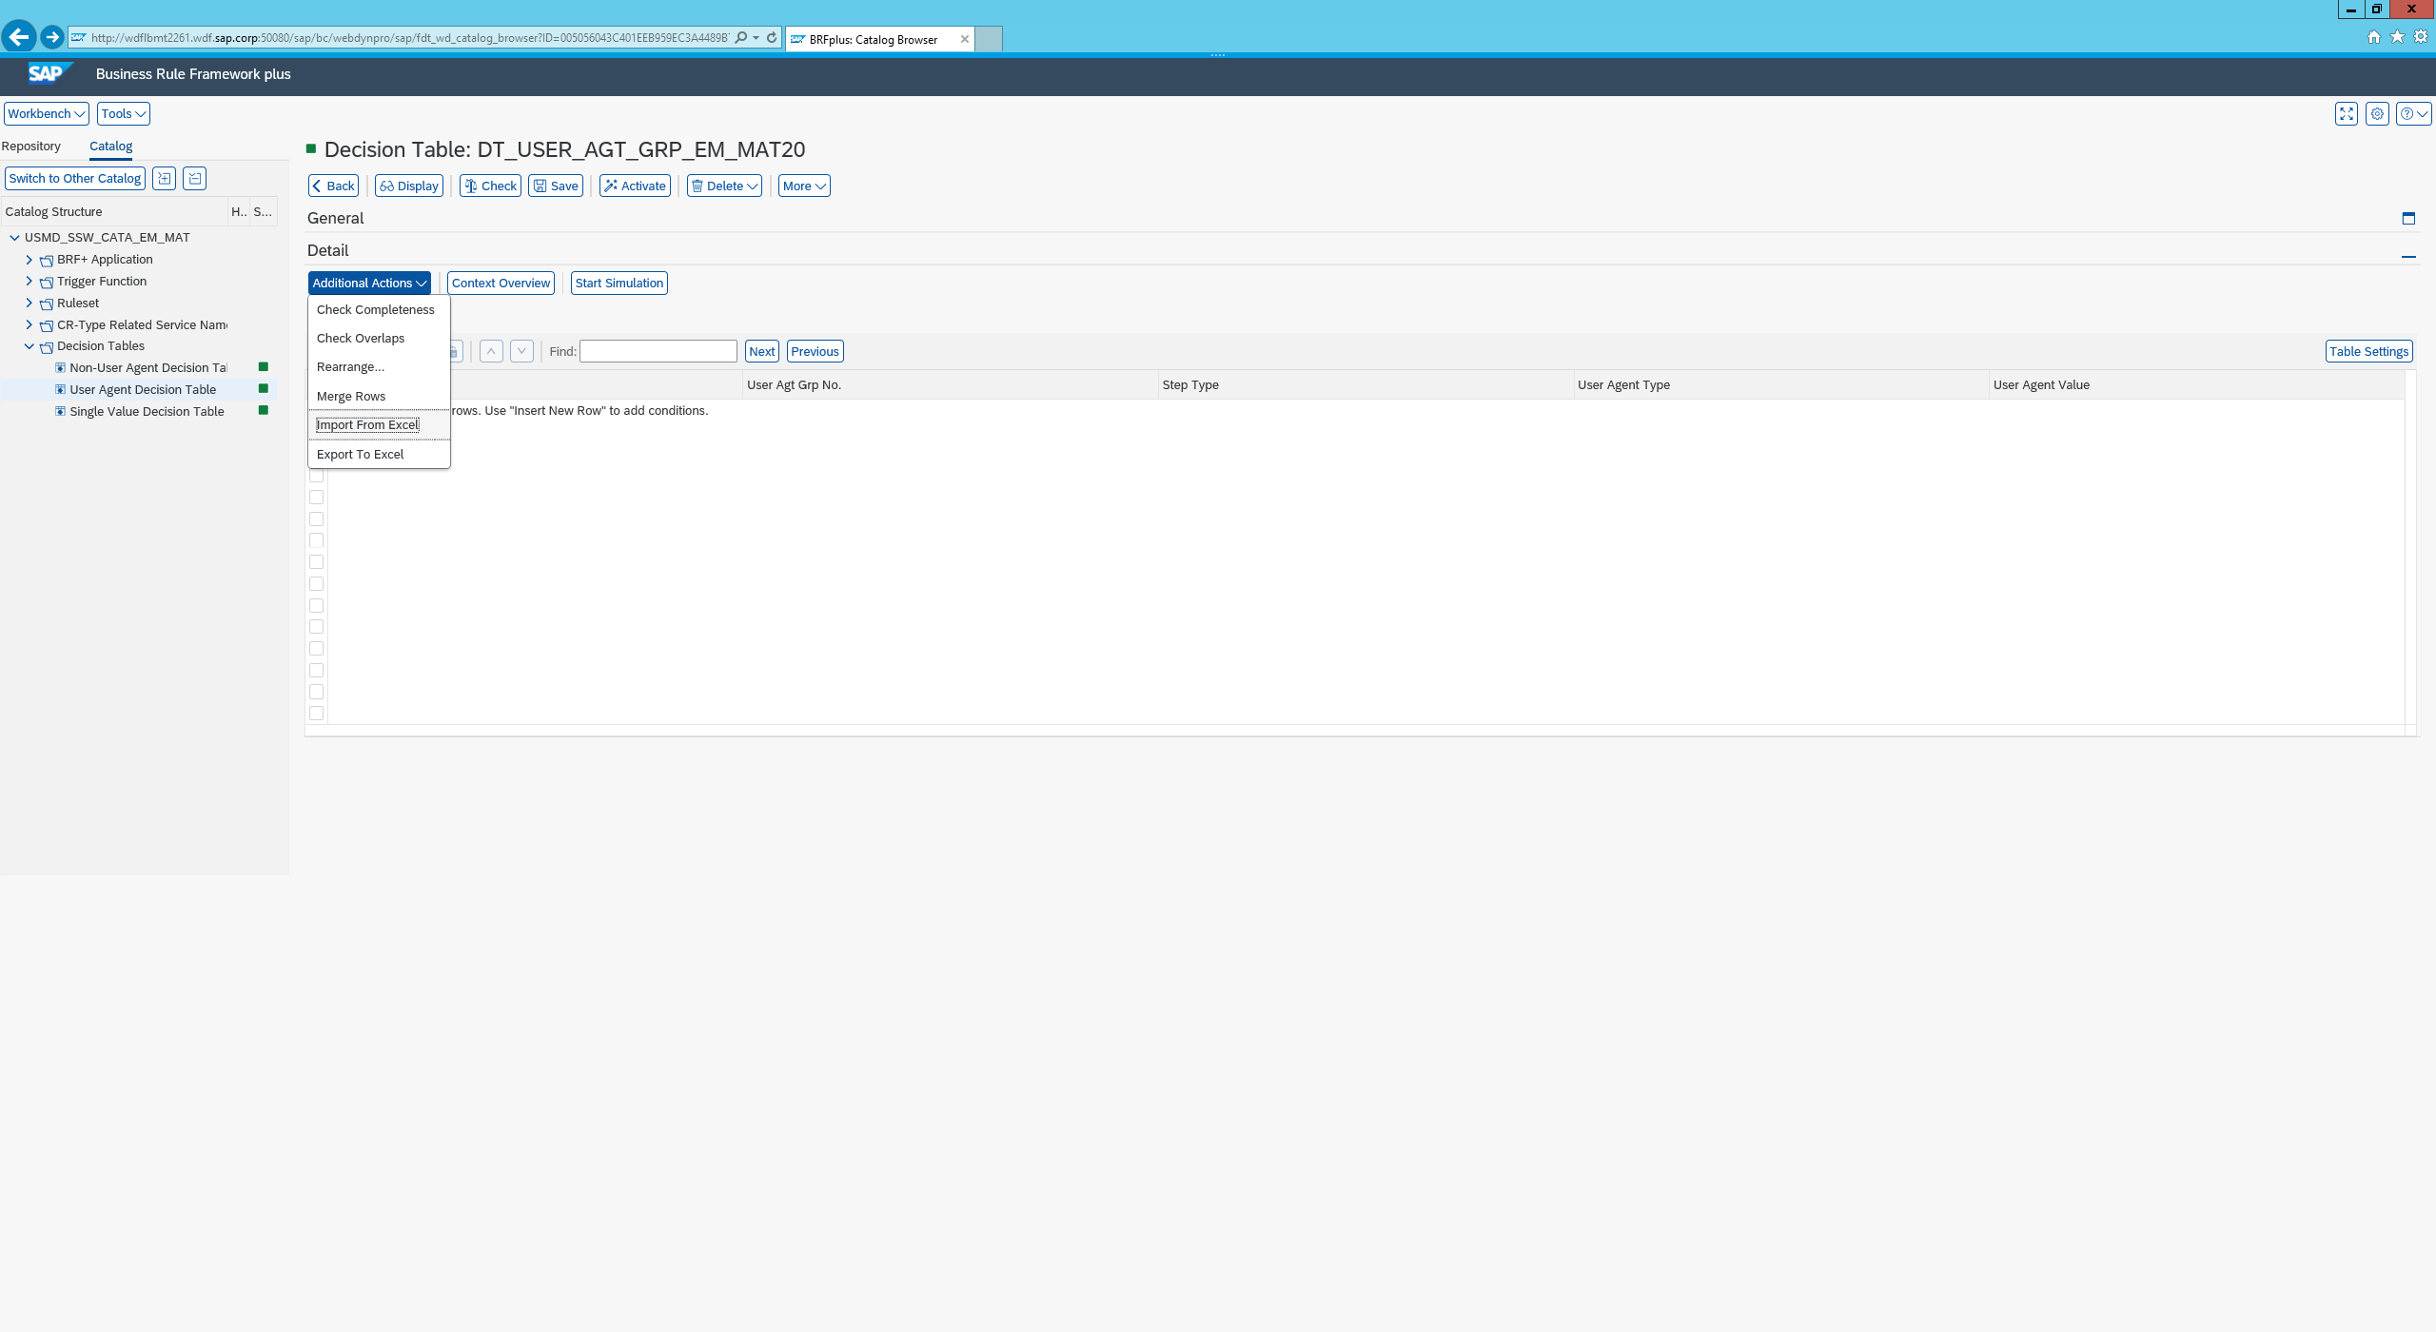

Configure the Decision table

i) Open Single Value Decision table 🡪 Select the step highlighted below Copy and paste

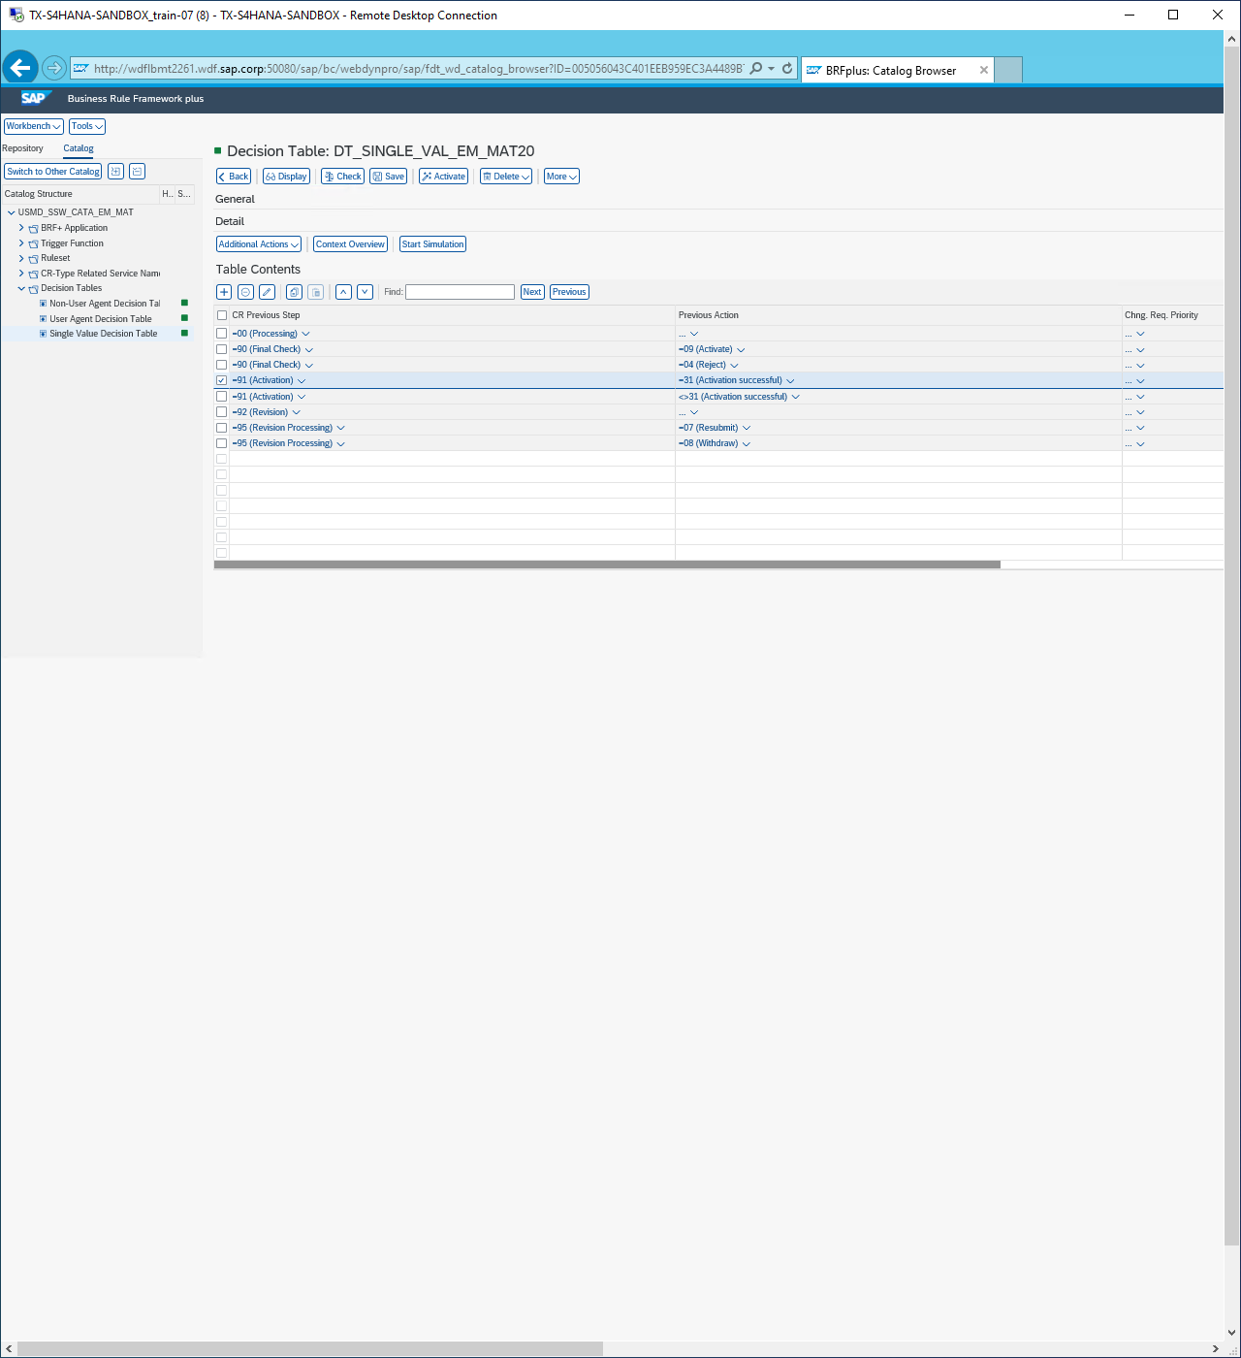

ii)With the newly copied step scroll across 🡪 Change the following Values:

New Change req Step: SY (This is the step we created previously)

New CR Status: 02

Condition Alias: Change to whatever you like I changed to SY.

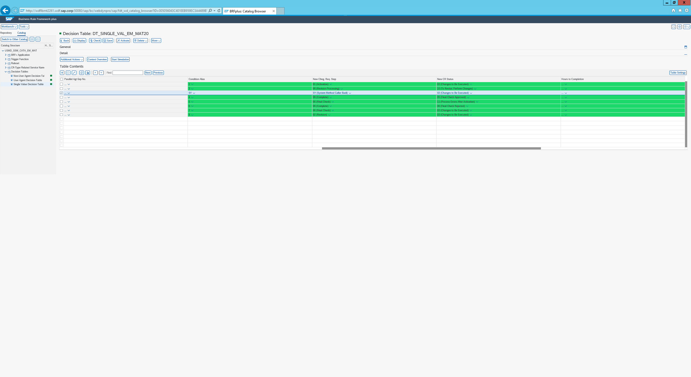

iii) For the row below that you originally copies and did not change do the following

iV ) Change the previous step from 91 to SY and remove the previous action as 91 is done in the backend so no action is needed.

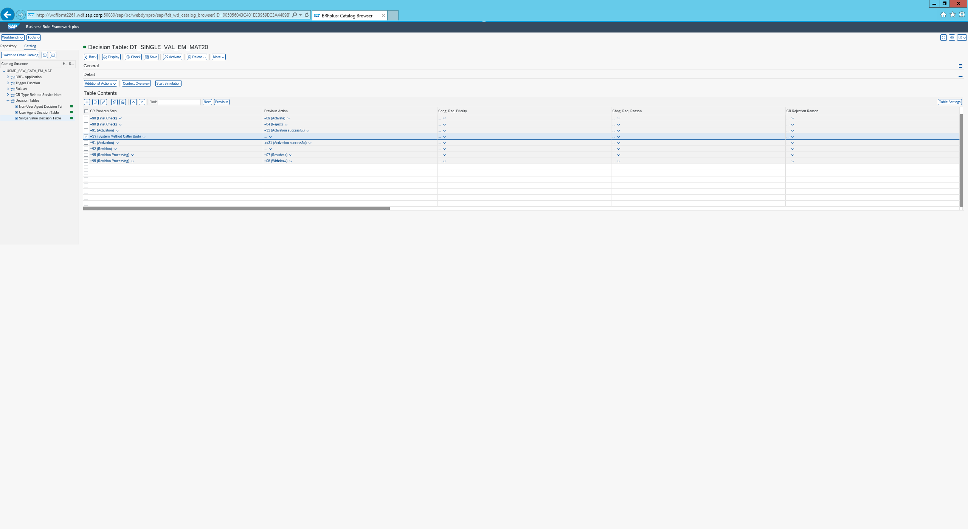

v) Open the NonUser Agent Decision table

vi) Here we need to create an additional row 🡪 Insert the details as follows below..

vii) Ensure the Service name is entered correctly with the service you created 🡪 Lastly make sure you activate each table.

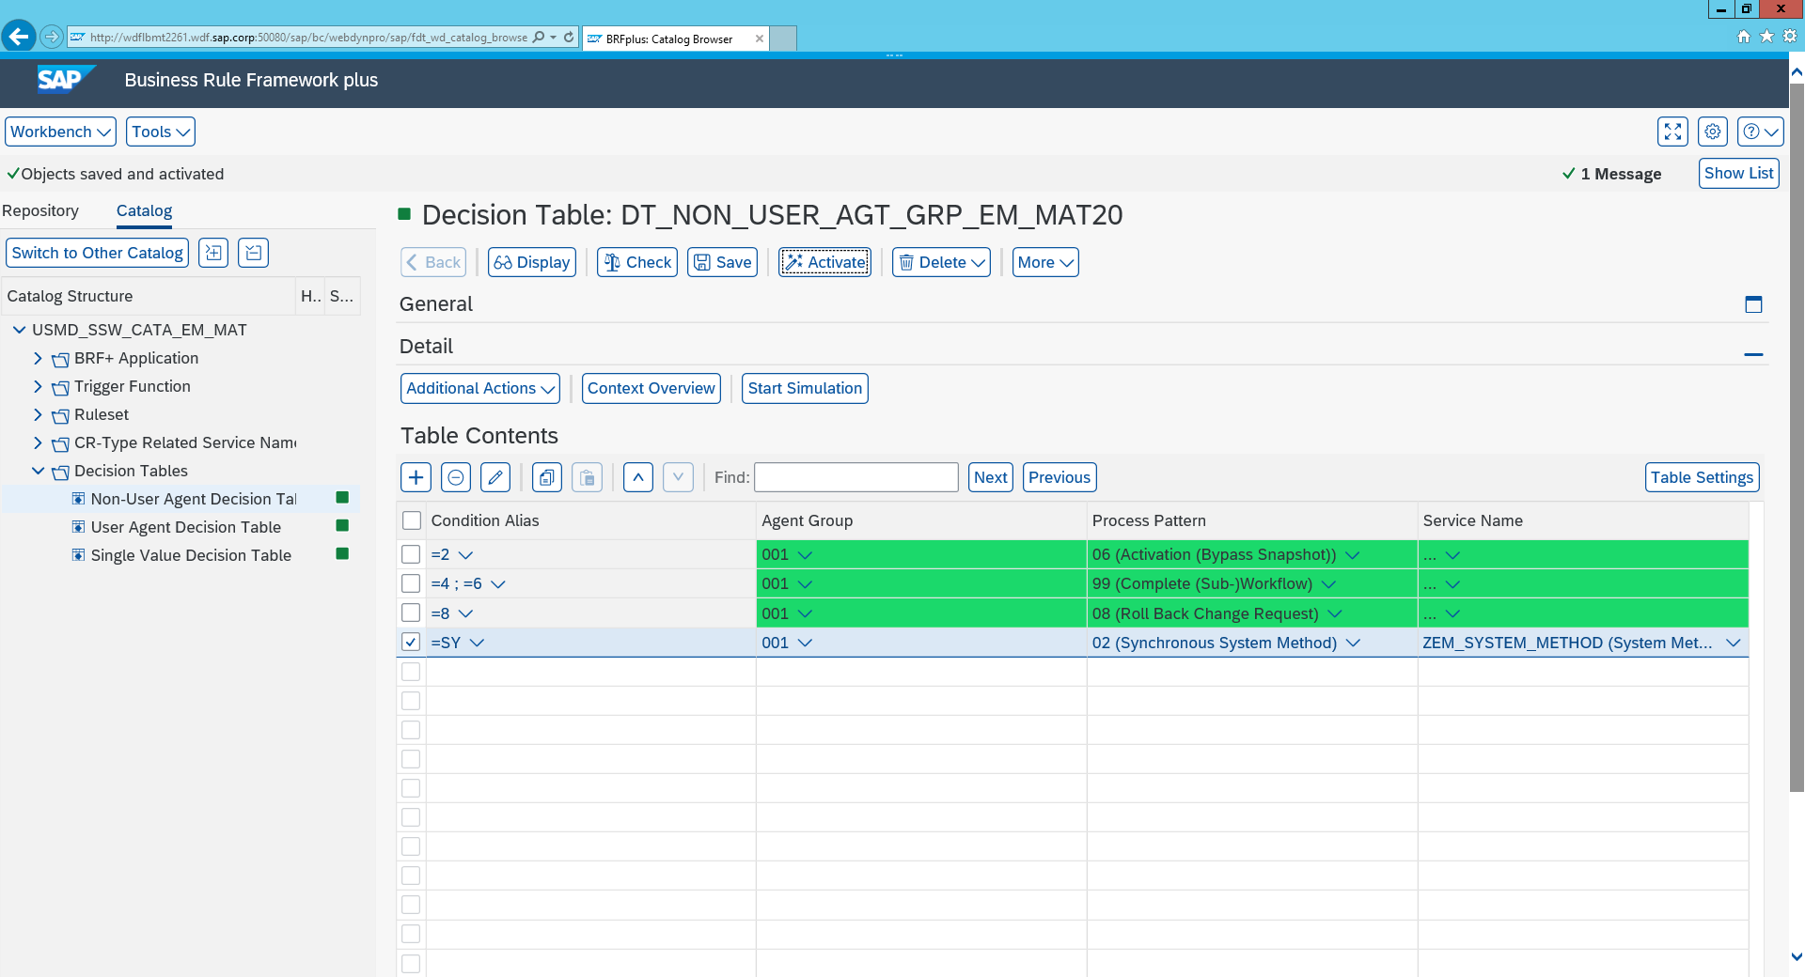

BADI Implemntation

i) Open General settings 🡪 Process Modelling 🡪 Workflow 🡪 Rule-Based workflow 🡪 Business Add-Ins 🡪 BAdi: Calling of System Method for Rule Based Workflow

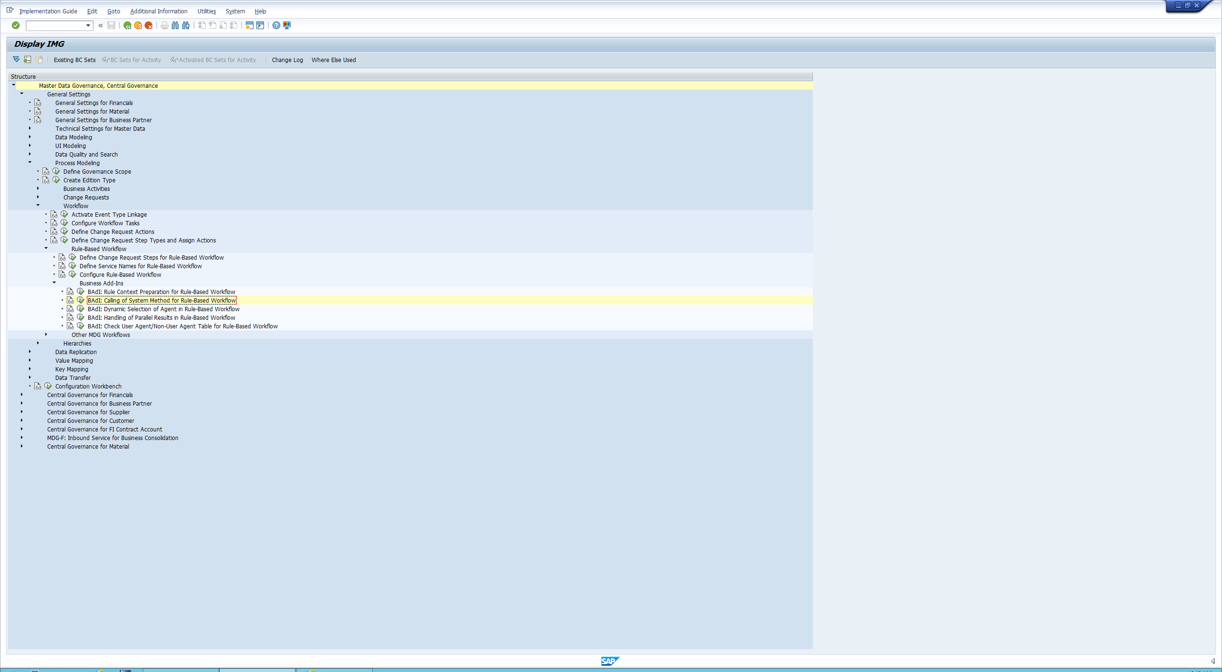

ii) Click create new enter the following values

Enhancement Implementation: ZEI_SYSTEM_CALLER_MAT02

Short text: System method caller badi for follow up CR MAT02

iii) click continue 🡪 local package

iv) Enter the two values as follows:

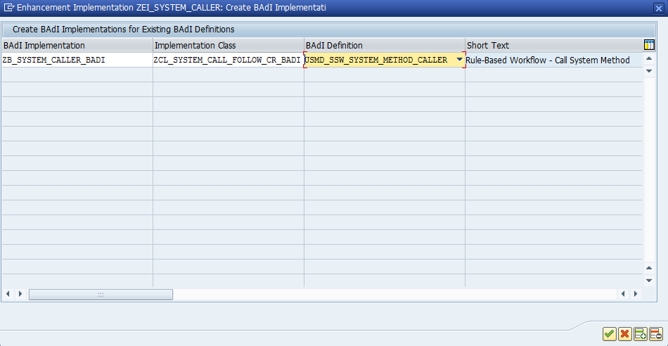

v) Next you will be shown another example class, so you click copy sample class 🡪 Save

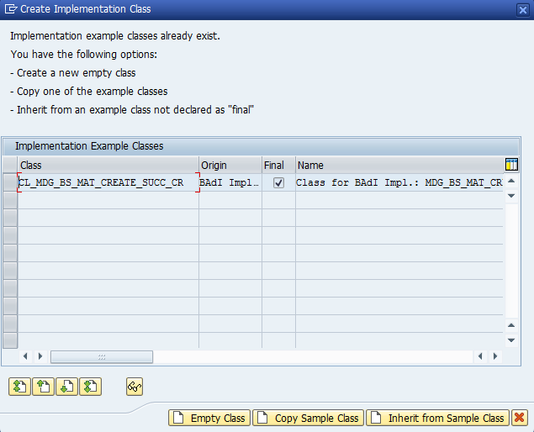

vi) Click on Filter from the side menu and add a filter 🡪 Click combination 🡪 double click the yellow page and enter your service value

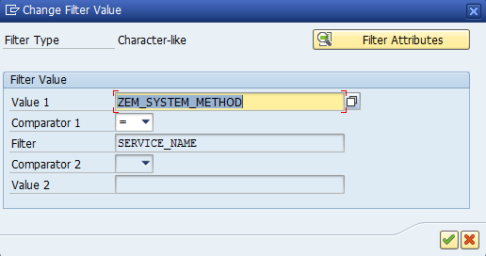

vii) click implementing class 🡪 double click the method 🡪 change line 15 highlighted below. Insert your service eg WHEN ‘ZEM_SYSTEM_METHOD’

